Automated Attendance Portal using facial recognition and RFID

Anmol Jain  
*Computer Science Department Professor*  
*Kiet Group Of Institutions*Ghaziabad   
anmol.jain@kiet.edu

Devraj Gupta  
 *Computer Science Department  
Student*  
*Kiet Group Of Institutions*Ghaziabad   
dev.2024cs1025@kiet.edu Anand Parashar  
 *Computer Science Department  
Student*  
*Kiet Group Of Institutions*Ghaziabad   
anand.2024cs1105@kiet.edu

Ansh Srivastava  
 *Computer Science Department  
Student*  
*Kiet Group Of Institutions*Ghaziabad   
ansh.2024cs1162@kiet.edu Antriksh Tyagi  
 *Computer Science Department  
Student*  
*Kiet Group Of Institutions*Ghaziabad   
antriksh.2024cs1203@kiet.edu

*Abstract*—Traditional methods for documenting classroom attendance, such as roll-calls and sign-in sheets, are inefficient, error-prone, and susceptible to fraudulent entries. While some alternatives exist, they often remain expensive and impractical, failing to address fake attendance. This paper presents a low-cost, efficient solution utilizing Real-Time Face Recognition technology. By employing algorithms like Haar Cascade Classifier and LBPH for face detection and recognition, integrated with Python, OpenCV, MySQL, Apache server, and PHP, the system ensures accurate and tamper-proof attendance records. This platform significantly enhances efficiency and reliability, fostering trust among students, educators, and administrators.

Keywords—HaarCascadeClassifier,LBPH,PHP,OpenCV,Apache

**I. I**NTRODUCTION

d This project presents the development of an Image-Based Attendance System for Educational Institutions, aimed at resolving the critical inefficiencies and inaccuracies inherent in traditional attendance management methods. Traditional systems, such as roll-calls and sign-in sheets, are plagued by issues such as fraudulent attendance, where an individual might record attendance on behalf of another without the institution's knowledge. This not only compromises the reliability of the data but also requires considerable human resources to enforce, making it impractical. Moreover, these systems are notably time-consuming; for instance, if each student takes approximately one minute to sign in, only 60 students can record their attendance within an hour, leading to significant inefficiency. Another major drawback is the limited accessibility of attendance information to concerned stakeholders, such as parents, who often lack timely access to their wards' attendance records, thus creating a gap in accountability.[1]

To address these challenges, our research aims to develop an intelligent attendance management system utilizing facial recognition technology. This approach leverages advanced image processing techniques to enhance efficiency and accuracy.[2] Facial recognition technology typically employs two methodologies: the feature-based approach, which identifies distinctive landmarks on the face such as eyes, nose, and mouth, and the brightness-based approach, which evaluates the entire image. Our system integrates these methodologies with modern technological tools to ensure precise recognition. Images of students' faces are captured using strategically placed cameras in classrooms. These images are then processed with techniques like grayscale conversion and histogram equalization to improve quality before undergoing face detection and recognition.[5]

The significance of this project lies in its ability to create a robust, tamper-proof attendance management system. By comparing real-time images with pre-stored photos in a database, the system ensures accurate attendance marking, thus eliminating the potential for fraudulent entries. This technology not only enhances the efficiency of attendance tracking but also builds trust among students, educators, and administrators by providing reliable data. Additionally, by allowing authorized stakeholders, such as parents, timely access to attendance information, the system promotes transparency and accountability, making it a pivotal solution in modern educational environments. Through this project, we aim to set a new standard in attendance management, significantly contributing to the improvement of institution.[6]

**II L**ITERATURE SURVEY

In this project we have discussed a variety of topics in brief which are related to the system methodologies, algorithms, emerging technologies, advancements, future directions etc.

Attendance management is a fundamental aspect of educational institutions, ensuring accountability, monitoring student engagement, and facilitating effective teaching practices. Traditional methods of attendance tracking, such as manual paper-based systems, have long been the norm. However, these methods are prone to errors, time-consuming, and lack real-time monitoring capabilities.[4] With the advent of digital technologies, there has been a paradigm shift towards automated attendance management systems, leveraging advancements in face recognition technology to streamline administrative processes and enhance efficiency.[5]

Recent years have witnessed significant advancements in face recognition technology, driven by breakthroughs in computer vision, machine learning, and artificial intelligence. Techniques such as Local Binary Patterns Histograms (LBPH) and Cascade Classifiers have emerged as powerful tools for face detection and recognition. These methods are capable of accurately identifying individuals from images or video streams, even in challenging conditions such as varying lighting, facial expressions, and occlusions.[7]

The integration of face recognition technology into attendance management systems represents a promising solution to the limitations of traditional attendance tracking methods. By automating the process of capturing and verifying student identities, these systems offer several advantages, including improved accuracy, real-time monitoring, and reduced administrative burden. Studies have shown that face recognition-based attendance systems can significantly enhance efficiency, enabling educators to focus more on teaching and student engagement.[9]

Numerous case studies have demonstrated the successful implementation of face recognition-based attendance management systems in educational institutions worldwide. These implementations vary in terms of system architecture, hardware requirements, and user interface design. For example, some institutions have deployed standalone face recognition terminals, while others have integrated facial recognition capabilities into existing infrastructure such as student ID cards or mobile applications.[9] Common themes across these case studies include the importance of user training, data privacy safeguards, and ongoing system maintenance to ensure the reliability and effectiveness of the attendance management system.[10]

Looking ahead, emerging trends in face recognition technology are poised to further revolutionize attendance management systems. Deep learning models, such as convolutional neural networks (CNNs), hold promise for achieving even higher levels of accuracy and robustness in face recognition tasks.[9] Additionally, the adoption of cloud-based solutions and mobile applications is expected to grow, offering scalability, flexibility, and accessibility for educational institutions of all sizes. Future research directions may focus on addressing challenges related to scalability, interoperability, and ethical considerations surrounding the use of biometric data in educational settings.[1]

In conclusion, automated attendance management systems powered by face recognition technology represent a significant advancement in the field of educational technology. By leveraging state-of-the-art face recognition algorithms and digital infrastructure, these systems offer educators and administrators a powerful tool for improving efficiency, accountability, and student engagement. As the technology continues to evolve, ongoing research and development efforts are essential to ensure the effectiveness, reliability, and ethical use of face recognition-based attendance management systems in educational environments.[7]

**III M**ETHODOLOGY

We present a cost-effective solution for recording student attendance through the implementation of face detection technology. Our proposed system, named IBAS (Image-Based Attendance System), comprises four key stages: image acquisition, face detection, attendance registration, and attendance monitoring. The primary objective is to enhance staff efficiency and reduce the workload, ultimately elevating the accuracy of attendance records. While conventional methods like fingerprint scans, retinal scans, and access cards are commonly used for attendance tracking, our paper advocates for the utilization of face recognition technology. Specifically, we employ the Haar cascades and LBPH algorithm to identify faces within images. This approach aims to automate classroom attendance without direct teacher involvement. Haar cascades offer a distinct advantage with their rapid face detection speed, making them superior to existing techniques. Custom Haar cascade classifiers are generated for each user, trained using positive or face-containing images. These classifiers are then utilized for face detection and recognition tasks. Our implementation encompasses four key stages: capturing video images, converting images to grayscale, storing them in a dataset for training, and finally, identifying faces and recording attendance based on input images with trained faces. Each identified face is associated with a corresponding student ID during dataset creation, ensuring accurate attendance tracking.

The core Viola and Jones face detection algorithm typically operates across 150 frames. However, to adapt these foundational techniques for diverse real-time applications, numerous developers and academics have refined them over recent years. One approach involves applying the face detection algorithm solely to segmented regions post-background subtraction, effectively reducing computational complexity. In our implementation, we employ a wavelet transform for face detection. Wavelet coefficient subsets are utilized to represent the item's shape, while integral images facilitate the computation of Haar features. These features are derived by computing the variance difference between black and white regions within rectangles, a process facilitated by integral and squared integral images. This technique not only enhances computational efficiency but also ensures accurate face detection in real-time scenarios.

The initial phase of implementing an automated attendance tracking system involves registering each student in the class. It is imperative to thoroughly train the system to accurately identify the faces of individuals. Hence, through the initial step of face detection, the system extracts the faces of all relevant individuals from various photographs, compiling them into a dataset of grayscale images with dimensions of 200x200 pixels. For each unit, a collection of photos containing that unit is provided as input. During this phase, the system detects and captures faces from the input photographs, subsequently converting them into grayscale images

Following the conversion process, each image file is meticulously labelled with a unique identifier, typically comprising the student's ID and USN (University Serial Number), thus facilitating further recognition of their identity. To enhance the precision of face recognition, it is imperative to train the system with diverse conditions encompassing the faces of all members involved. This comprehensive training regimen ensures that the system can accurately identify and register students' attendance under varying circumstances.

The dataset now contains images of all class members captured under various conditions. Once these images are trained, they are converted into NumPy arrays. To label the test dataset obtained from the class, the trained classifier file is saved. Each class member's representative image serves as the input. The process commences with face detection to locate all faces, followed by identification using a local binary pattern histogram (LBPH). Subsequently, grayscale images are generated, and the classifier learned from training is employed for face recognition. Each recognized face is then assigned a Student ID label, facilitating accurate attendance tracking.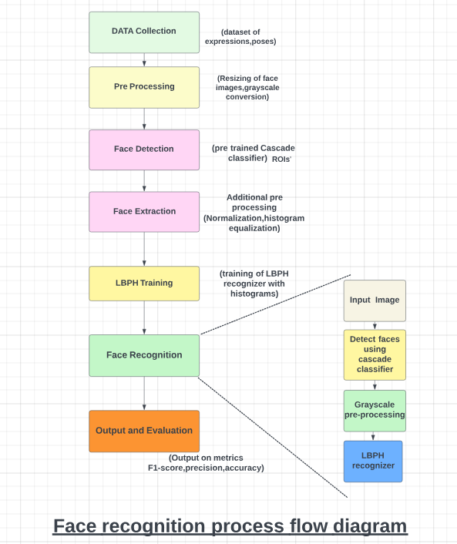

**Figure 1-Face Recognition Process Flow Diagram**

**IV P**ROPOSED SYSTEM

In our proposed system, the system is instantiated by the mobile. After it triggers then the system starts processing the image of the students for which we want to mark the attendance.

Image Capturing phase is one in which we capture the image of the students. This is the very basic phase from which we start initializing our system. We capture an image from our camera which predominantly checks for certain constraints like lightning, spacing, density, facial expressions etc. The captured image is resolute according to our requirements. Once it is resolute, we make sure it is either in .png or .jpeg format.

We take different frontal postures of an individual so that accuracy can be attained to the maximum extent. This is the training database in which we classify every individual based on labels. For the captured image, from every object we detect only frontal faces. This detects only face and removes every other part since we are exploring the features of faces only. These detected faces are stored somewhere in the database for further enquiry. Features are extracted in the extraction phase.

The detected bounding boxes are further queried to look for features extraction and the extracted features are stored in a matrix. For every detected phase, this feature extraction is done. Features that we look here are shape, edge, colour, auto-correlation, and LBP. Face is recognized once we complete the extracting features. The features which are already trained with every individual is compared with the detected faces features and if both features match, then it is recognized. Once it recognizes, it is going to update in the student attendance database. Once the process is completed, the testing images remain.

Usually, a roll no. call is taken to determine whether the student is present in the class or not, which usually wastes a lot of time. In recent years, with the emerging technology and with the development of deep learning, face recognition has made great achievements, which leads us to a new way of thinking to solve the problem of student enrolment. So, to save time, the idea to count the number of students in a class automatically based on face recognition is incorporated. This system is developed by using face recognition technique which is used to detect the face of an individual. There are many different face recognition algorithms introduced to increase the efficiency of the system. The system provides an increased accuracy due to the use of many features like Shape, colour, LBPH, Auto- Correlation etc. of the face. However, face recognition remains a challenging problem for us because of its fundamental difficulties regarding various factors like illumination changes, face rotation, facial expression etc.

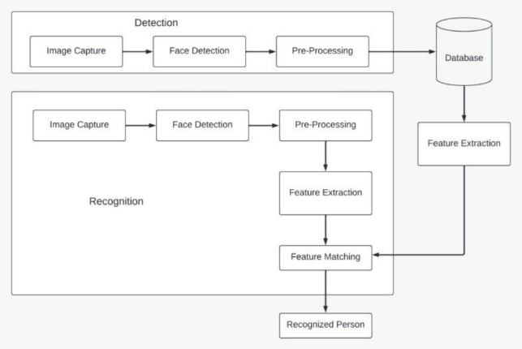

**Figure 2- System Model**

**Figure 3-System Architecture**

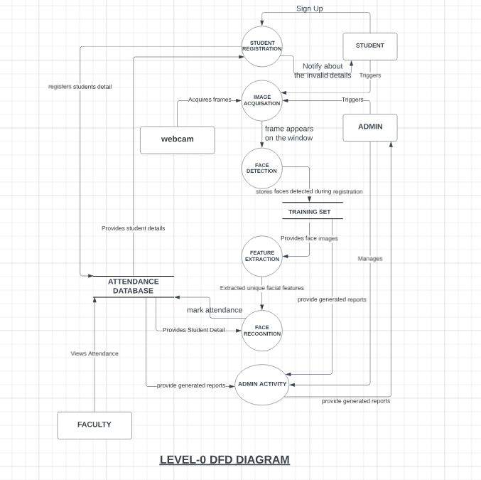

**Figure 4-Level-0 DFD Diagram**

**V I**MPLEMENTED ALGORITHMS

1)LBPH (Local Binary Histograms Patterns)

Face recognition is essentially the task of identifying a person based on their facial appearance in computer science. In the past two decades, it has greatly increased in popularity, largely due to new techniques created and the excellent quality of the most recent recordings and cameras. The Local Binary Pattern (LBP) texturing operator labels each pixel in an image by thresholding its immediate surroundings and treating the result as a binary number. Furthermore, it has been discovered that using LBP in conjunction with HOG descriptors significantly enhances detection performance on specific datasets. We can express the images of faces using a straightforward data vector by using the LBP in conjunction with histograms. As LBP is a visual descriptor it can also be used for face recognition tasks, as can be seen in the following step-by-step explanation.

1) Parameters: the LBPH uses 4 parameters:

1. Radius: the radius is used to build the circular local binary pattern and represents the radius around the central pixel.
2. Neighbors: the number of sample points to build the circular local binary pattern. ·
3. Grid X: the number of cells in the horizontal direction. ·
4. Grid Y: the number of cells in the vertical direction.

2) Training the Algorithm: We must first train the algorithm. We must use a dataset containing the facial photographs of the persons we wish to identify to accomplish this. For the algorithm to identify an input image and provide you with a result, we also need to set a Student ID for each image.

3) Applying the LBP operation: The initial computational phase of the LBPH is to produce an intermediate image that, by emphasizing the face features, more accurately describes the original image. The algorithm does this by utilizing a sliding window idea based on the radius and neighbors of the parameter. Suppose we have a facial image in grayscale. We can get part of this image as a window of 3x3 pixels. It can also be represented as a 3x3 matrix containing the intensity of each pixel (0-255). The matrix's central value must then be used as the threshold, which is what we must do next. We establish a new binary value for each neighbor of the threshold value. The matrix will now only have binary values. Each binary value from each point in the matrix must be concatenated, line by line, into a new binary value. The central value of the matrix, which is a pixel from the original image, is then set to this binary value after being converted to a decimal value. At the conclusion of this process (the LBP technique), we obtain a new image that more accurately captures the traits of the original image.

4) Extracting the Histograms: As we have an image in grayscale, each histogram (from each grid) will contain only 256 positions (0-255) representing the occurrences of each pixel intensity. Then, we need to concatenate each histogram to create a new and bigger histogram.

5) Performing the face recognition: The algorithm has already been trained at this point. Each histogram produced serves as a representation of one of the training dataset's images. Therefore, given an input image, we repeat the process for the new image and produce a histogram that symbolizes the image. Simply compare two histograms and return the image with the closest histogram to identify the image that matches the input image. The distance between two histograms can be calculated using a variety of methods, such as the Euclidean distance, chi-square, absolute value, etc. So, the algorithm output is the ID from the image with the closest histogram. The algorithm should also return the calculated distance, which can be used as a ‘confidence’ measurement. We can then use a threshold and the ‘confidence ‘to automatically estimate if the algorithm has correctly recognized the image. We can assume that the algorithm has successfully recognized if the confidence is lower than the threshold defined.

2)HCC A (Haar Cascade Classifier)

Haar classifier, or a Haar cascade classifier, is a machine learning object detection program that identifies objects in an image and video. The algorithm can be explained in four stages:

1. Calculating Haar Features
2. Creating Integral Images
3. Using Adaboost
4. Implementing Cascading Classifiers

It’s important to remember that this algorithm requires a lot of positive images of faces and negative images of non-faces to train the classifier, like other machine learning models.

1) Calculating Haar Features: Gathering the Haar features is the initial stage. In a detection window, a Haar feature is effectively the result of calculations on adjacent rectangular sections. To calculate the difference between the sums, the pixel intensities in each region must first be added together. Identifying these elements in a large photograph can be challenging. This is where integral images come into play because the number of operations is reduced using the integral image.

2) Creating Integral Images: Without going into too much of the mathematics behind it, integral images essentially speed up the calculation of these Haar features. Instead of computing at every pixel, it instead creates sub-rectangles and creates array references for each of those sub-rectangles. These are then used to compute the Haar features.

3) AdaBoost Training: In essence, Adaboost selects the top features and trains the classifiers to use them. The algorithm can detect objects by using a "strong classifier" that is made by combining several "weak classifiers." By sliding a window across the input image and computing Haar characteristics for each area of the image, weak learners are produced. This distinction is contrasted with a learnt threshold that distinguishes between non-objects and objects. Since these are "weak classifiers," creating a strong classifier requires a lot of Haar features to be accurate.

4) Implementing Cascading Classifiers**:** Each level of the cascade classifier is made up of weak learners. It consists of a sequence of phases. A highly accurate classifier can be created from the mean prediction of all weak learners by employing boosting during the training of weak learners. The classifier either chooses to go on to the subsequent region (negative) or decides to indicate that an object was identified (positive) based on this prediction. Stages are made to reject negative samples as quickly as possible because the bulk of the windows don't contain anything of interest.

Haar-cascade is a method, in which it trains machine learning for detecting objects in a picture. It can be used to detect faces. The basic idea of the Haar-based face detector is that if you look at most frontal faces, the region with the eyes should be darker than the forehead and cheeks, and the region with the mouth should be darker than cheeks, and so on.

It typically performs about 20 stages of comparisons like this to decide if it is a face or not, but it must do this at each possible position in the image and for each possible size of the face, so in fact it often does thousands of checks per image. The name of this method is composed of two important words, Haar and Cascade. Haar belongs to Haar-like features which is a weak classifier and will be used for face recognition.

A Haar-like feature is a rectangle which is split into two, three or four rectangles. Each rectangle is black or white. This shows the different possible features. A Haar- cascade needs to be trained with various positive and negative pictures. The objective is to extract the combination of these features that represent a face. While a positive picture contains the object which must be recognized, a negative picture represents a picture without the object.

**VI R**ESULTS AND DISSCUSSIONS

**Figure 5- Practical Testing**

**Figure 6- Practical Testing 1**

**Fig 5** depicts the comparison between the training time and the number of images in the data set.

And, finally, **Fig 6** compares the recognition time it takes the system to recognize n number of faces.

The users can interact with the system using a GUI. Here, users will be mainly provided with three different options such as student registration, faculty registration, and mark attendance.

1. The students are supposed to enter all the required details in the student registration form. After clicking on the register button, the webcam starts automatically.
2. The webcam will capture 50 images to create the image dataset and then terminate automatically.
3. At the time of forming the image dataset, each student will get designated using an id number. While recognition, when the test student image matches with the dataset then the details of the student in the attendance excel sheet will be marked with a timestamp, if the test student image does not get matched with the dataset, then it will not be marked present, and all the unmatched students will be marked as absent after a certain period.

The following Images shows the nature of the system when it is fed with different size of datasets. Here we compare 3 groups of 2 data.

|  |  |  |
| --- | --- | --- |
| **View (Distance between camera and face between 35-100cm approx.)** | **ANGLE (In Degrees)** | **Recognition Rate in Normal Light Conditions** |
| **LEFT** | **30**  **45**  **90** | **100**  **99**  **0** |
| **CENTRE** | **0** |  |
| **RIGHT** | **30**  **45**  **90** | **100**  **97**  **0** |

**Table 1-Recognition Rate at Different Angles**

For Left view, between,0 and 45 degrees the recognition rate is 99-100 percent. After 45 degrees the rate starts decreasing and goes to zero at 90 degrees angles. For Right view, between,0 and 45 degrees the recognition rate is 97-100 percent. After 45 degrees the rate starts decreasing and goes to zero at 90 degrees angles. And, for 0 degrees, the recognition rate is 100 percent.

**VI C**ONCLUSION

The Attendance Management System utilizing facial recognition technology exemplifies the successful integration of modern technological advancements into traditional educational processes. This project addresses the critical need for a seamless, automated solution for tracking student attendance, leveraging sophisticated machine learning algorithms and real-time data processing to ensure accuracy and efficiency, thereby eliminating manual entry errors.

A key achievement of this system is its real-time operation, which saves valuable time for educators and ensures tamper-proof attendance records. The use of RFID technology enhances the system's robustness, linking each student's attendance data securely to their unique identifier. A comprehensive backend database, implemented with MySQL and managed via an Apache server, securely stores and facilitates easy retrieval of attendance data for analysis and reporting.

The system's modular design, incorporating PHP modules for various functions such as student registration, attendance logging, and report generation, ensures efficient data management and supports multiple users simultaneously. This approach facilitates maintenance, updates, and scalability, enhancing the system's overall efficiency and reliability.

Looking forward, the system holds numerous opportunities for enhancement, including the integration of advanced deep learning algorithms to improve accuracy and speed, even in challenging conditions. The development of mobile applications for iOS and Android platforms could provide greater flexibility and convenience, allowing educators and students to interact with the system from anywhere within the institution.

Integrating the Attendance Management System with other educational tools and platforms, such as Learning Management Systems (LMS), could provide a holistic view of student engagement, correlating attendance data with academic performance to identify students needing additional support. Advanced analytics and predictive models could offer deeper insights into student behaviour and attendance patterns, enabling proactive interventions.

Incorporating additional biometric technologies, such as fingerprint scanning, voice recognition, and iris scanning, could provide multi-modal biometric authentication, further increasing the system's accuracy and security.

In conclusion, the Attendance Management System is a pioneering solution that addresses the need for efficient, accurate, and secure attendance tracking in educational institutions. Its current implementation demonstrates the potential of facial recognition technology and RFID integration in streamlining administrative processes. With future developments in deep learning, mobile applications, system integration, and advanced analytics, this system can evolve into a comprehensive tool that enhances the overall educational experience. By continuing to innovate, this project has the potential to set new standards in attendance management and make significant contributions to educational technology.

**VII R**EFRENCES

[1] Shreyak Sawhney, Karan Kacker, Samyak Jain, Shailendra Narayan Singh, Rakesh Garg, “Real-Time Smart Attendance System using Face Recognition Techniques”, 2020

[2] Naman Gupta, Purushottam Sharma, Vikas Deep, Vinod Kumar Shukla, “Automated Attendance System Using OpenCV”, 2019

[3] Krishna Mridha, Nabhan Tawjih Yousef, “Study and Analysis of Im- plementing a Smart Attendance Management System Based on Face Recognition Technique using OpenCV and Machine Learning”, 2021

[4] Organization, S. D. I. W. C., Kuster, B. (2018). Face Detection and Face Recognition in Python Programming Language. The Seventh International Conference on Informatics and Applications (ICIA2018).

[5] Emami, Shervin Suciu, Valentin. (2012). Facial Recognition using OpenCV. Journal of Mobile, Embedded and Distributed Systems.

[6] Yuvaraj, C. Srikanth, M. Kumar, V. Srinivasa Murthy, Y.V. Koolagudi, Shashidhar. (2017). An approach to maintain attendance using image processing techniques. 1-3. 10.1109/IC3.2017.8284353.

[7] Nirmalya Kar, Mrinal Kanti Debbarma, Ashim Saha, and Dwijen Rudra Pal. Study of Implementing Automated Attendance System Using Face Recognition Technique. International Journal of Computer and Commu- nication Engineering, Vol. 1, No. 2, July 2012.

[8] Suma S L, Sarika Raga, “Real Time Face Recognition of Human Faces by using LBPH and Viola Jones Algorithm,” International Journal of Scientific Research in Computer Science and Engineering, Vol.6, Issue.5, pp.6-10, 2018.

[9] Ahonen, T., Hadid, A., Pietikäinen, M.: Face description with local binary patterns: Application to face recognition. PAMI 28(12), 2037–2041 (2006)

[10] Ojala, T., Pietikäinen, M., Mäenpää, T.: Multiresolution Grayscale and Rotation Invariant Texture Classification with Local Binary Patterns. PAMI 24(7), 971–987 (2002)

[11] Zhang, W., Shan, S., Zhang, H., Gao, W., Chen, X.: Multi-resolution histogram of local variation patterns (MHLVP) for Robust Face Recognition. In: Kanade, T., Jain, A., Ratha, N.K. (eds.) AVBPA 2005. LNCS, vol. 3546, pp. 937–944. Springer, Heidelberg (2005)

[12] Huang, X., Li, S.Z., Wang, Y.: Jensen-Shannon Boosting Learning for Object recognition. In: Proceeding of CVPR (2005)

[13] Raja, Y., Gong, S.: Sparse Multiscale Local Binary Patterns. In: Proc. 17thBMVC (2006)

[14] Rodriguez, Y., Marcel, S.: Face authentication using adapted local binary pattern histogram. In: Leonardis, A., Bischof, H., Pinz, A. (eds.) ECCV 2006. LNCS, vol. 3954, pp. 321–332. Springer, Heidelberg (2006).